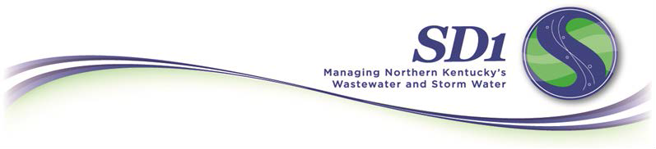

Frequently Asked Questions
Public Culvert Cost-Share Program

What is SD1’s public culvert cost-share program?
Culverts are a vital component of the stormwater conveyance system in communities across Northern Kentucky. As a result, both SD1 and its city/county co-permittees have a vested interest in the rehabilitation and replacement of deteriorating culverts. For this reason, SD1 allocates funding through the public culvert cost-share program to help co-permittees complete publicly owned culvert capital improvement projects such as culvert lining or replacement. This program does not include maintenance-related work.

Who may apply?
All SD1 co-permittees are eligible to participate in the public culvert cost-share program for publicly owned culverts, but cities and counties must apply for funding. The amount of funding available for this program is determined each fiscal year as part of SD1’s budgeting process.

How can someone apply?
Applications are available at https://forms.sd1.org/Forms/CostShareApplication.

How are public culvert cost-share program projects prioritized?

In general, projects are funded on a first-come, first-served basis while funds are available. Should SD1 receive more applications in a year than budgeted funds allow, SD1 will further prioritize projects based on rating criteria included in the program application. Only projects associated with a dedicated right-of-way will be considered for funding.
When is funding released for approved projects?
SD1 provides funding as a reimbursement currently (50%) of culvert project costs. To receive approved funding, participants must enter into an agreement with SD1 and the project must begin within 12 months of the application’s approval. Throughout construction, SD1 will inspect the culvert improvements to ensure they meet specifications. Upon completion of the project, participants must submit a request for reimbursement that includes copies of invoices and payment receipts.
Public Culvert Cost-Share Program FAQ – p. 2 of 2

Once a project is complete, who is responsible for the culvert?
Cities and counties own the culverts and are responsible for their ongoing maintenance. SD1 is simply providing additional funding for major capital improvements to the culvert.

Who should I contact with questions?
If you have any questions regarding this program, please contact Andy Aman by phone at 859-578-6800 or by email at aaman@sd1.org.

Thank you for your cooperation and support as we work together to protect public health, property and the environment by providing reliable wastewater and stormwater services.

