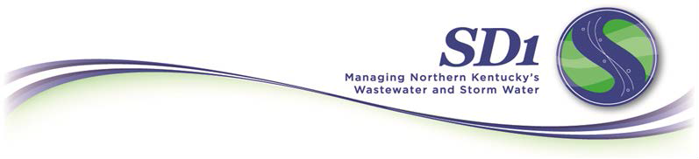

Frequently Asked Questions
Technical Assistance Program

What is SD1’s storm water technical assistance program?
As part of the regional stormwater program, SD1 has employed the technical assistance program to help communities and co-permittees with stormwater drainage issues. This program applies when the extent of the problem is not clear, and the possible solutions and the degree of their effectiveness is not apparent. The program applies to private property drainage issues or public drainage issues where a co-permittee is exploring the effectiveness of various alternatives. Under this program, SD1 will evaluate storm-water-related issues and develop planning-level solutions. These are not detailed design plans, but rather concept-level solutions. Under this program SD1 will evaluate the severity of the issue, determine any system deficiencies and develop alternatives based on these findings. Additionally, SD1 will evaluate whether any of the concept-level solutions would qualify for other SD1 storm water programs, such as Public Cost-Share, Private Cost-Share or Public Culvert Cost-Share.

Who may apply?
All SD1 co-permittees are eligible to participate in the technical assistance program. Property owners in need of technical assistance for storm water drainage issues must contact their city or county to participate in the program. SD1 will accept requests for technical assistance only from co-permittees. The amount of funding available for this program is determined each fiscal year as part of SD1’s budgeting process.

How can someone apply?
Applications are available at https://forms.sd1.org/Forms/CostShareApplication.

How are technical assistance program projects prioritized?
In general, projects are funded on a first-come, first-served basis while funds are available.

Technical Assistance FAQ – p. 2 of 2
How are results communicated to co-permittees?
Upon completion of the study, SD1 will meet with the co-permittee and property owners to explain the results of the concept plan. SD1 will also explain whether any of the proposed solutions would qualify under other SD1 storm water programs.

Who should I contact with questions?
If you have any questions regarding this program, please contact Andy Aman by phone at 859-578-6880 or email aaman@sd1.org.

Thank you for your cooperation and support as we work together to protect public health, property and the environment by providing reliable wastewater and storm water services.

